
Innovation & Entrepreneurship Hub for Educated Rural Youth (SURE Trust – IERY)

VIGNAN DIARIES
(Blogging and Content Publishing Platform)

The domain of the Project:
Full Stack Development

Team Mentors (and their designation):

Ms. A Akshara
(Software Developer at Propel Technology)

Team Members:
Varsha Naradasu
(G30 FSD)

Period of the project March 2026 to April 2026



Innovation & Entrepreneurship Hub for Educated Rural Youth (SURE Trust – IERY)

Declaration
The project titled “Vignan Diaries” has been mentored by Ms A Akshara (Software Developer at Propel Technology), organised by SURE Trust, from April 2023 to August 2023, for the benefit of the educated unemployed rural youth for gaining hands-on experience in working on industry relevant projects that would take them closer to the prospective employer. I declare that to the best of my knowledge the members of the team mentioned below, have worked on it successfully and enhanced their practical knowledge in the domain.

Team Members:
Ms. Naradasu Varsha

Ms A Akshara
Software Developer at Propel Technology

Prof. Radhakumari
Executive Director & Founder
SURE Trust

TABLE OF CONTENTS

ABSTRACT 1
- INTRODUCTION 2
  - Introduction 2
  - Project Background 2
  - Problem Statement 3
  - Objectives 3
  - Benefits of the Proposed Platform 4
- SCOPE OF THE PROJECT 5
  - Scope 5
  - Functional Scope (Modules) 5
    - User Authentication Module 5
    - Blog Management Module 5
    - Interaction Module (Likes and Comments) 6
    - Dashboard Module 6
  - Uniqueness and Project Highlights 6
- EXISTING SYSTEM VS PROPOSED SYSTEM 7
  - Existing System 7
  - Proposed System 7
  - Comparison Table 8
  - Feature Summary (What I Implement) 8
- ARCHITECTURAL DIAGRAM 9
  - Architecture Overview 9
  - Architecture Description 9
    - User Layer 9
    - Frontend Layer (React.js) 9
    - Backend Layer (Node.js + Express.js) 10
    - Database Layer (MongoDB) 10
  - System Flow 11
  - Advantages of the Architecture 11
i
  - Architecture Diagram 11
- ERD DIAGRAM 13
  - ERD Explanation 13
    - User Entity 13
    - Post Entity 13
    - Comment Entity 14
    - Like Entity 14
  - Relationships 15
  - ERD Diagram 15
- TECH STACK USED 16
  - Frontend: React.js 16
  - Backend: Node.js and Express.js 16
  - Database: MongoDB Atlas 17
  - Tools and Deployment 17
- SCREENSHOTS OF THE CODE AND PROJECT 18
  - Project Screenshots (UI) 18
  - Code Screenshots 20
- URLs 23
  - GITHUB URL 23
  - DEPLOYED URL 23

ii

List of Figures
  - System Architecture Diagram 12
  - Entity Relationship Diagram of Blogging Platform 15
  - Homepage displaying recent blogs 18
  - Blog editor page for creating and publishing posts 18
  - User dashboard showing all blog entries 19
  - Comment, like, and share features 19
  - AI Implementation 20
  - JWT Auth Controller (Backend) 20
  - Auth Protection Middleware 21
  - Post Lifecycle API (Draft to Publish) 21
  - Post Engagement Routes (Express) 22
  - Frontend Post Page (Likes + Comments Integration) 22

iii

ABSTRACT

The Blogging and Content Publishing Platform is a full-stack web application designed to provide users—especially students and beginner content creators—with an efficient and secure environment to create, manage, and publish digital content. In today’s digital world, blogging has become an essential tool for sharing knowledge, expressing ideas, and building professional identity. This project aims to bridge the gap between simple content creation tools and advanced publishing systems by offering a user-friendly, scalable, and feature-rich platform.
The system is developed using the MERN stack (MongoDB, Express.js, React.js, and Node.js), which ensures high performance, scalability, and maintainability. The frontend is implemented using React.js, providing a responsive and dynamic user interface. The backend is powered by Node.js and Express.js, offering RESTful APIs for handling all operations. MongoDB is used as the database to store user information, blog posts, drafts, and interactions efficiently.
The platform enables users to perform complete blog lifecycle operations, including creating posts, editing content, saving drafts, publishing articles, and deleting posts. It also supports user engagement through features such as likes, comments, and view tracking, encouraging interaction and feedback among users. Secure authentication is implemented using JWT (JSON Web Tokens), ensuring protected access to user-specific features and safeguarding sensitive information.
To maintain system integrity and security, the platform includes input validation, sanitization, and password hashing mechanisms. These measures help prevent common vulnerabilities such as unauthorized access and malicious input. Additionally, the system design supports scalability and future enhancements such as admin moderation, advanced analytics, content categorization, and recommendation systems.
Overall, this project provides a modern, secure, and user-centric blogging solution that promotes creativity, knowledge sharing, and digital learning. It also serves as a practical implementation of full-stack development concepts, making it highly valuable for academic and real-world applications.

1

CHAPTER - 1 INTRODUCTION

Introduction

In the modern digital landscape, content creation has become one of the most powerful mediums for communication, learning, and self-expression. Blogging platforms enable in-dividuals to share ideas, document experiences, publish tutorials, and contribute knowledge to a wider audience. With the rapid growth of internet accessibility, digital content con-sumption has increased significantly, making blogging an essential tool for both personal and professional development.
Blogging platforms play a crucial role in allowing users to express their thoughts in an organized and structured manner. For students, blogging is particularly beneficial as it improves writing skills, enhances critical thinking, and helps in building a strong academic or professional portfolio. It also encourages creativity and independent learning by providing a platform to showcase projects, ideas, and technical knowledge.
In addition, modern users expect applications to be fast, responsive, and easy to use across multiple devices. A well-designed blogging platform must provide seamless navigation, efficient content management, and interactive features such as commenting, liking, and sharing. Security is also a major concern, as user data must be protected from unauthorized access and misuse. Therefore, a modern blogging system should combine usability, performance, and security in a balanced manner.

Project Background

Traditional methods of sharing written content in academic and informal environments include printed notes, documents, PDFs, and messaging platforms. These approaches often lack proper organization, accessibility, and interactivity. It becomes difficult to update content, search for specific information, or engage with readers effectively.
The introduction of web-based blogging platforms has addressed many of these limitations by providing a centralized and interactive system for publishing content. Such platforms allow users to create, edit, and manage posts efficiently while making them accessible to a global audience. Additionally, features like comments and likes enable users to interact and share feedback, creating a collaborative learning environment.
This project utilizes the MERN stack (MongoDB, Express.js, React.js, Node.js),

2

which is widely used in modern web development. The MERN stack offers a powerful combination of technologies that support scalability, flexibility, and performance. By using this stack, the platform ensures efficient handling of data, smooth user interface rendering, and seamless communication between frontend and backend systems.

Problem Statement

Despite the availability of several blogging platforms, many of them come with limitations that reduce their effectiveness, especially for students and beginner users. Some platforms require paid subscriptions to access advanced features, while others provide limited cus-tomization and control in their free versions. Additionally, certain platforms have complex interfaces that make it difficult for new users to create and manage content efficiently.
Another major issue is the lack of proper engagement and interaction features. Some systems do not provide efficient comment handling, tagging systems, or real-time interaction capabilities. Security is also a concern, as weak authentication mechanisms may lead to unauthorized access or data misuse.
Therefore, there is a need for a free, secure, and user-friendly blogging platform that overcomes these challenges. The system should allow users to:

    - Register securely and manage their accounts.

    - Create, edit, and publish blog posts easily.

    - Interact with other users through comments and likes.

    - Access the platform seamlessly across devices.

Objectives

The main objective of this project is to design and develop a full-stack blogging platform that is simple, efficient, and secure. The system aims to provide all essential blogging features while maintaining ease of use for beginners.
The specific objectives include:

    - To develop a web-based blogging system using the MERN stack.

    - To implement secure user authentication using JWT (JSON Web Tokens).

    - To enable users to create, edit, delete, and publish blog posts.

    - To provide interactive features such as likes, comments, and filtering.

3

    - To design a responsive and mobile-friendly user interface.

    - To ensure proper validation and security for user data.

    - To deploy the application on a live platform for real-time access.

Benefits of the Proposed Platform

The proposed platform offers several advantages for different types of users, making it both academically valuable and practically useful.

    - Students: It helps students document their learning, build portfolios, and improve writing and analytical skills.
    - Readers: Users can explore informative content, gain knowledge, and interact with authors through feedback and discussions.
    - Developers/Learners: The platform provides a real-world example of full-stack development, helping learners understand frontend-backend integration.
    - Content Creators: It enables users to publish ideas easily without requiring advanced technical knowledge.

Overall, the system promotes knowledge sharing, enhances communication, and provides a structured platform for digital content creation. It also demonstrates practical implementation of modern web technologies, making it highly relevant for academic and industry purposes.

4

CHAPTER - 2 SCOPE OF THE PROJECT

Scope

The scope of the Blogging and Content Publishing Platform includes the complete lifecycle of content creation, management, and interaction. The platform is designed to support both authors and readers, ensuring that users can securely access features based on authentication status.
The system supports secure user registration and login, followed by a dashboard where authenticated users can manage their content. A dedicated editor enables users to write posts, update them, store them as drafts, and publish them when ready. Published content becomes accessible to all users on the public feed.
In addition to author features, the platform supports reader engagement. Users can like posts, comment on posts, and contribute to discussions. View tracking can be used to measure post reach, and additional filtering/search options can help users find content.

Functional Scope (Modules)

User Authentication Module
      - User registration with input validation.

      - User login and JWT token issuance.

      - Protected routes to restrict dashboard and post management.

      - Secure password storage using hashing.

Blog Management Module
      - Create posts with title, content, and optional tags.

      - Save posts as drafts for later completion.

      - Publish posts for public visibility.

      - Edit and update existing posts.

5

      - Delete posts securely with authorization checks.

      - Unique slug generation for clean post URLs.

Interaction Module (Likes and Comments)
      - Like/unlike posts to support engagement.

      - Add comments to posts with validation.

      - Display all comments under each post.

      - View count tracking (optional enhancement) for analytics.

Dashboard Module
      - Display a list of user posts.

      - Separate draft and published posts for clarity.

      - Quick actions to edit, delete, and publish.

Uniqueness and Project Highlights

This platform is unique and especially useful for students because it emphasizes simplicity while providing real-world full-stack functionality:

- Student-first design: easy navigation, simple editor, and structured dashboard.

- Draft support: encourages iterative writing and learning workflows.

- Secure architecture: JWT authentication and hashed passwords protect accounts.

- Community-driven engagement: likes and comments encourage interaction.

- Scalable MERN stack: modular architecture supports future upgrades such as admin moderation.

6

CHAPTER - 3
EXISTING SYSTEM VS PROPOSED SYSTEM

Existing System

Many existing blogging platforms provide basic publishing functionality, but several limi-tations can affect students and new creators:
    - Cost restrictions: advanced features such as customization, analytics, and domain support are locked behind subscriptions.
    - Limited customization: free tiers may restrict layout changes, post formatting tools, or integration options.
    - Complex workflows: beginners may struggle with complicated editors, publishing steps, or configuration.
    - Weak engagement features: some platforms do not provide smooth comment man-agement or modern interaction UI.
    - Moderation challenges: free systems may lack filtering, spam prevention, or proper validation.
    - Learning limitations: students cannot easily understand the full-stack flow when using closed commercial systems.
These issues show the need for an open, student-friendly alternative that provides both usability and modern development practices.

Proposed System

The proposed platform addresses the above issues by implementing a modern MERN-based blogging system with essential functionality:
    - Free platform: core features are available without payment.
    - Secure authentication: JWT-based login, protected routes, and password hashing.
    - Complete post management: create, edit, delete, save drafts, and publish.
    - Engagement features: likes and comments support community building.
7

    - Responsive UI: smooth usage on mobile and desktop devices.
    - Safer content handling: validation and sanitization with optional profanity filtering.

Comparison Table

Existing System | Proposed System
Premium subscriptions required for advanced features | Free student-friendly platform with core blogging features
Limited customization options in free versions | Flexible UI and scalable architecture using React + REST APIs
May provide weak or inconsistent authentication mechanisms | JWT authentication, protected routes, and hashed password storage
Draft support may be absent or limited | Draft + Publish workflow to support writing in steps
Interaction features may be basic or poorly integrated | Likes, comments, and view tracking for engagement
Moderation and spam controls may be limited | Input validation, sanitization, and optional profanity filtering
Not suitable for full-stack learning because it is closed-source | Clear MERN-based architecture suitable for academic full-stack learning
Table 3.1: Existing System vs Proposed System

Feature Summary (What I Implement)

The features implemented in this project include:

    - Secure user registration and login (JWT).
    - Create/edit/delete blog posts.
    - Draft saving and publishing.
    - Public blog feed for readers.
    - Like and comment functionality.
    - Responsive UI and API-based backend integration.

8

CHAPTER - 4 ARCHITECTURAL DIAGRAM

Architecture Overview

The Blogging and Content Publishing Platform is designed using a layered client-server architecture, which separates the system into distinct layers for better organization and efficiency. The architecture consists of three main layers: the frontend (presentation layer), backend (application layer), and database (data layer). Each layer has a specific responsibility and communicates with other layers through well-defined interfaces.
This layered approach improves maintainability by allowing developers to modify one layer without affecting others. It also enhances scalability, as each layer can be inde-pendently upgraded or scaled based on system requirements. Additionally, the architecture ensures better security by controlling data flow and restricting direct access between layers.
The system follows a request-response model, where user actions are processed through the frontend, handled by backend APIs, and stored or retrieved from the database. This structured design makes the application efficient, modular, and easy to extend in the future.

Architecture Description

User Layer
The user layer represents the end-users who interact with the system through web browsers or mobile devices. Users can access the platform to read blog posts without authentication, while additional features such as creating posts, commenting, and managing content require user login.
Authenticated users have access to personalized dashboards where they can create, edit, and manage their posts. This layer focuses on providing a smooth and user-friendly experience, ensuring that users can easily navigate and interact with the system.

Frontend Layer (React.js)
The frontend layer is implemented using React.js, which provides a dynamic and responsive user interface. It is responsible for displaying content, handling user interactions, and sending requests to the backend.
9

The frontend includes several key pages:

      - Home page displaying published blog posts.

      - Post details page showing content along with comments.

      - Login and registration pages for authentication.

      - User dashboard for managing drafts and published posts.

      - Editor page for creating and updating blog content.

React uses a component-based architecture, allowing reusable UI components and ef-ficient state management. The frontend communicates with backend APIs using HTTP/HTTPS requests, typically through tools like Axios or Fetch. For protected operations, JWT tokens are included in requests to verify user identity.

Backend Layer (Node.js + Express.js)
The backend layer is developed using Node.js and Express.js, which handle application logic and API communication. It acts as an intermediary between the frontend and the database.
The backend performs several critical functions:

      - Handles user authentication and authorization using JWT.

      - Provides RESTful APIs for all operations such as creating, updating, and deleting posts.
      - Manages comments and likes functionality.

      - Validates and sanitizes user input to ensure data integrity and security.

      - Processes requests and sends appropriate responses to the frontend.

Middleware is used to manage authentication and route protection, ensuring that only authorized users can access certain features. The backend also ensures error handling and proper response formatting.

Database Layer (MongoDB)
The database layer uses MongoDB, a NoSQL database that stores data in a flexible JSON-like format. It is responsible for storing all persistent data required by the application.
The database stores:

10

      - User information including credentials and profiles.

      - Blog posts with content, status, and metadata.

      - Comments and user interactions.

      - Like data for tracking engagement.

MongoDB provides flexibility in schema design, making it suitable for dynamic applications like blogging platforms. Indexing can be applied to improve performance for searching and retrieving data efficiently. The database interacts with the backend through Mongoose, which simplifies data modeling and querying.

System Flow

The overall system flow follows a structured sequence:
User → React Frontend → Express REST API → MongoDB Database → Response When a user performs an action (such as creating a post), the request is sent from the
frontend to the backend API. The backend processes the request, interacts with the database if needed, and sends the response back to the frontend. The frontend then updates the user interface accordingly.

Advantages of the Architecture

The chosen architecture provides several benefits:

- Clear separation of concerns between layers.

- Improved scalability and maintainability.

- Enhanced security through controlled data flow.

- Easy integration of new features and modules.

- Better performance and efficient data handling.

Architecture Diagram

The following diagram illustrates the overall system architecture, showing the interaction between user, frontend, backend, and database layers.
11

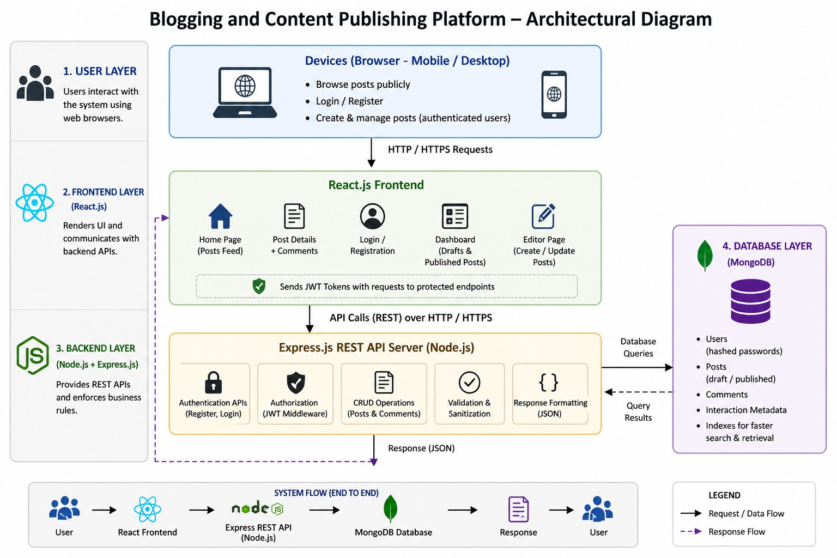
Figure 4.1: System Architecture Diagram

12

CHAPTER - 5 ERD DIAGRAM

ERD Explanation

The Entity Relationship Diagram (ERD) represents the logical structure of the database used in the Blogging and Content Publishing Platform. It illustrates how different entities are related to each other and how data is organized within the system. The ERD serves as a blueprint for database design and helps in ensuring data consistency, integrity, and efficient data retrieval.
The system is designed using a structured approach where each entity represents a real-world object, and relationships define how these entities interact. The main entities in the system include User, Post, Comment, and Like. These entities collectively support all functionalities such as authentication, content creation, and user interaction.

User Entity
The User entity stores all information related to registered users of the platform. It plays a central role in the system as all other entities are directly or indirectly linked to it.

Attributes:
      - User ID (Primary Key)
      - Name
      - Email
      - Password (stored in hashed form)
      - Role (optional: admin/user)
      - Created Date
Each user can create blog posts, comment on posts, and like posts. Authentication and authorization are handled based on user credentials.

Post Entity
The Post entity represents the blog content created by users. It stores all necessary details required to publish and manage posts.
13

Attributes:

      - Post ID (Primary Key)

      - Title

      - Content

      - Author ID (Foreign Key referencing User)

      - Status (Draft/Published)

      - Created Date

      - Updated Date

Each post is associated with one user and can have multiple comments and likes.

Comment Entity
The Comment entity stores user feedback and discussions related to blog posts.

Attributes:

      - Comment ID (Primary Key)

      - Content

      - Post ID (Foreign Key referencing Post)

      - User ID (Foreign Key referencing User)

      - Created Date

Comments enable interaction between users and enhance engagement on the plat-
form.

Like Entity
The Like entity is used to represent user interactions with posts in terms of appreciation or interest.

Attributes:

      - Like ID (Primary Key)

      - User ID (Foreign Key referencing User)
14

      - Post ID (Foreign Key referencing Post)

This entity helps track how many users liked a particular post and supports engage-ment analytics.

Relationships

The relationships between the entities are defined as follows:

- User to Post (One-to-Many): One user can create multiple posts, but each post is created by only one user.
- Post to Comment (One-to-Many): One post can have multiple comments.
- User to Comment (One-to-Many): One user can write multiple comments.
- User to Post (Many-to-Many via Like): A user can like multiple posts, and each post can be liked by multiple users.
These relationships ensure proper linkage between entities and maintain referential integrity in the database.

ERD Diagram

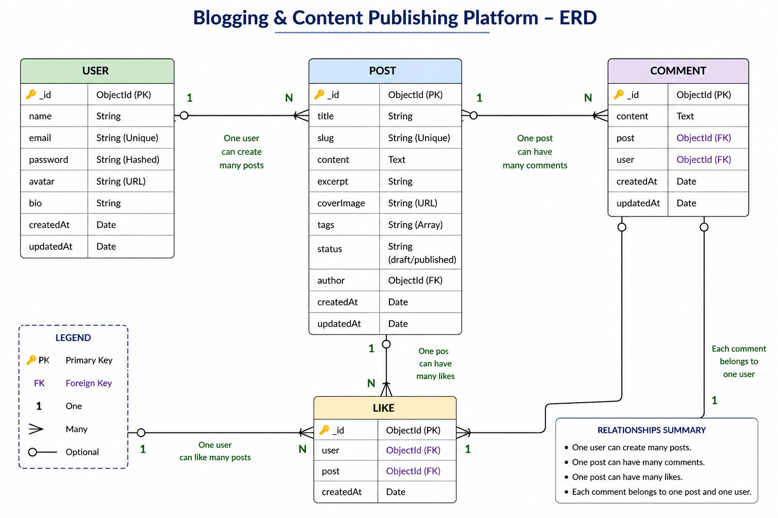

Figure 5.1: Entity Relationship Diagram of Blogging Platform 15

CHAPTER - 6 TECH STACK USED

Frontend: React.js

The frontend of the application is developed using React.js, a popular JavaScript library used for building dynamic and responsive user interfaces. React enables the creation of reusable components, which improves development efficiency and maintainability. It also provides fast rendering using a virtual DOM, ensuring a smooth user experience.
Key advantages of using React include:

    - Component-based architecture for reusable UI elements.

    - Faster rendering using Virtual DOM.

    - Smooth navigation with better user experience.

    - Easy integration with backend APIs using Axios or Fetch.

Backend: Node.js and Express.js

The backend is implemented using Node.js and Express.js, which together provide a pow-erful environment for building scalable server-side applications. Node.js allows handling multiple requests efficiently, while Express simplifies API development.
The backend is responsible for handling core application logic, including:

    - User authentication and authorization using JWT.

    - CRUD operations for blog posts.

    - Managing comments and likes functionality.

    - Input validation and sanitization for security.

    - Providing RESTful APIs for frontend communication.

16

Database: MongoDB Atlas

The application uses MongoDB Atlas, a cloud-based NoSQL database, to store and manage data. MongoDB stores data in flexible JSON-like documents, making it suitable for handling dynamic content such as blog posts and user interactions.
Reasons for selecting MongoDB include:

    - Flexible schema design for structured and unstructured data.

    - Easy scalability to handle growing data.

    - Seamless integration with Node.js using Mongoose.

    - Efficient data retrieval and indexing capabilities.

Tools and Deployment

Various tools are used during development, testing, and deployment to improve productivity and maintain code quality.

    - VS Code: Used for writing, editing, and debugging code efficiently.

    - Postman: Used for testing backend APIs and verifying responses.

    - GitHub: Used for version control and code management.

    - Render: Used for deploying the application and making it accessible online.

17

CHAPTER - 7
SCREENSHOTS OF THE CODE AND PROJECT

Project Screenshots (UI)

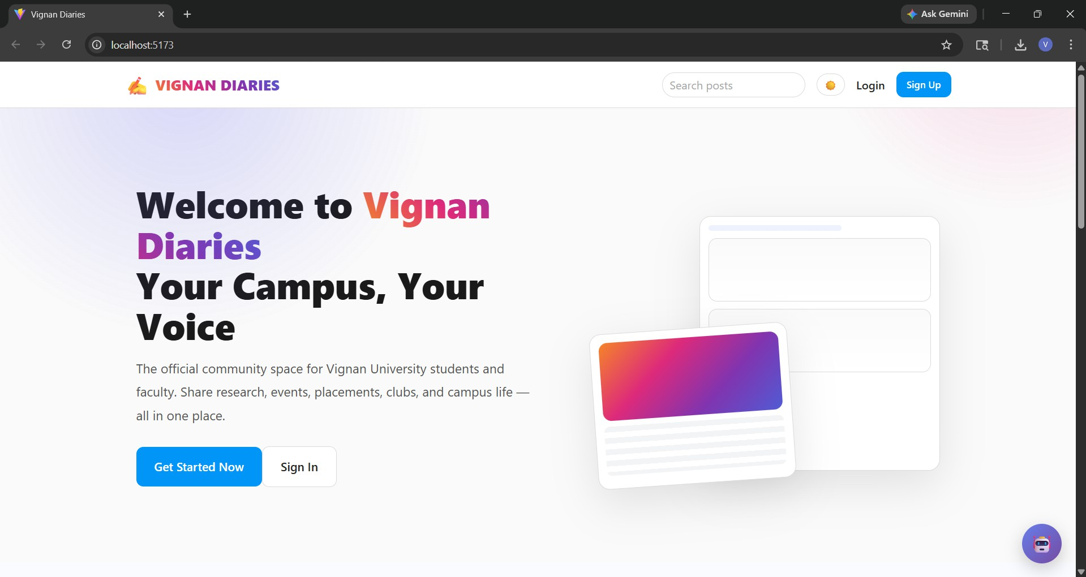

Figure 7.1: Homepage displaying recent blogs

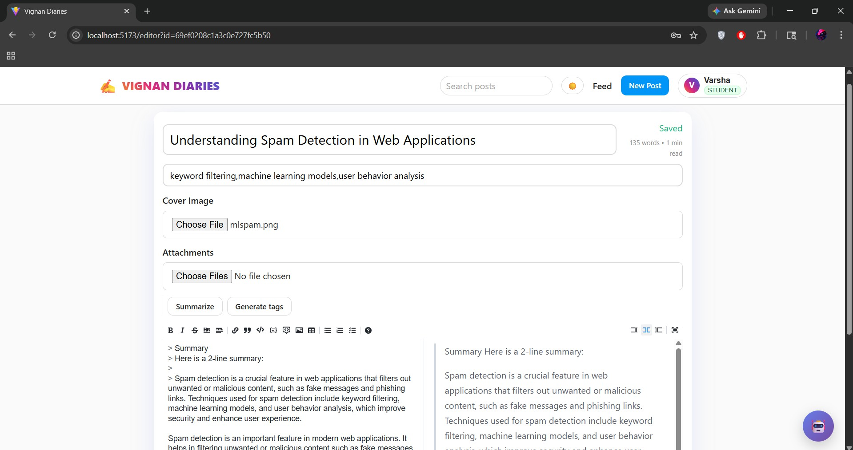

Figure 7.2: Blog editor page for creating and publishing posts

18

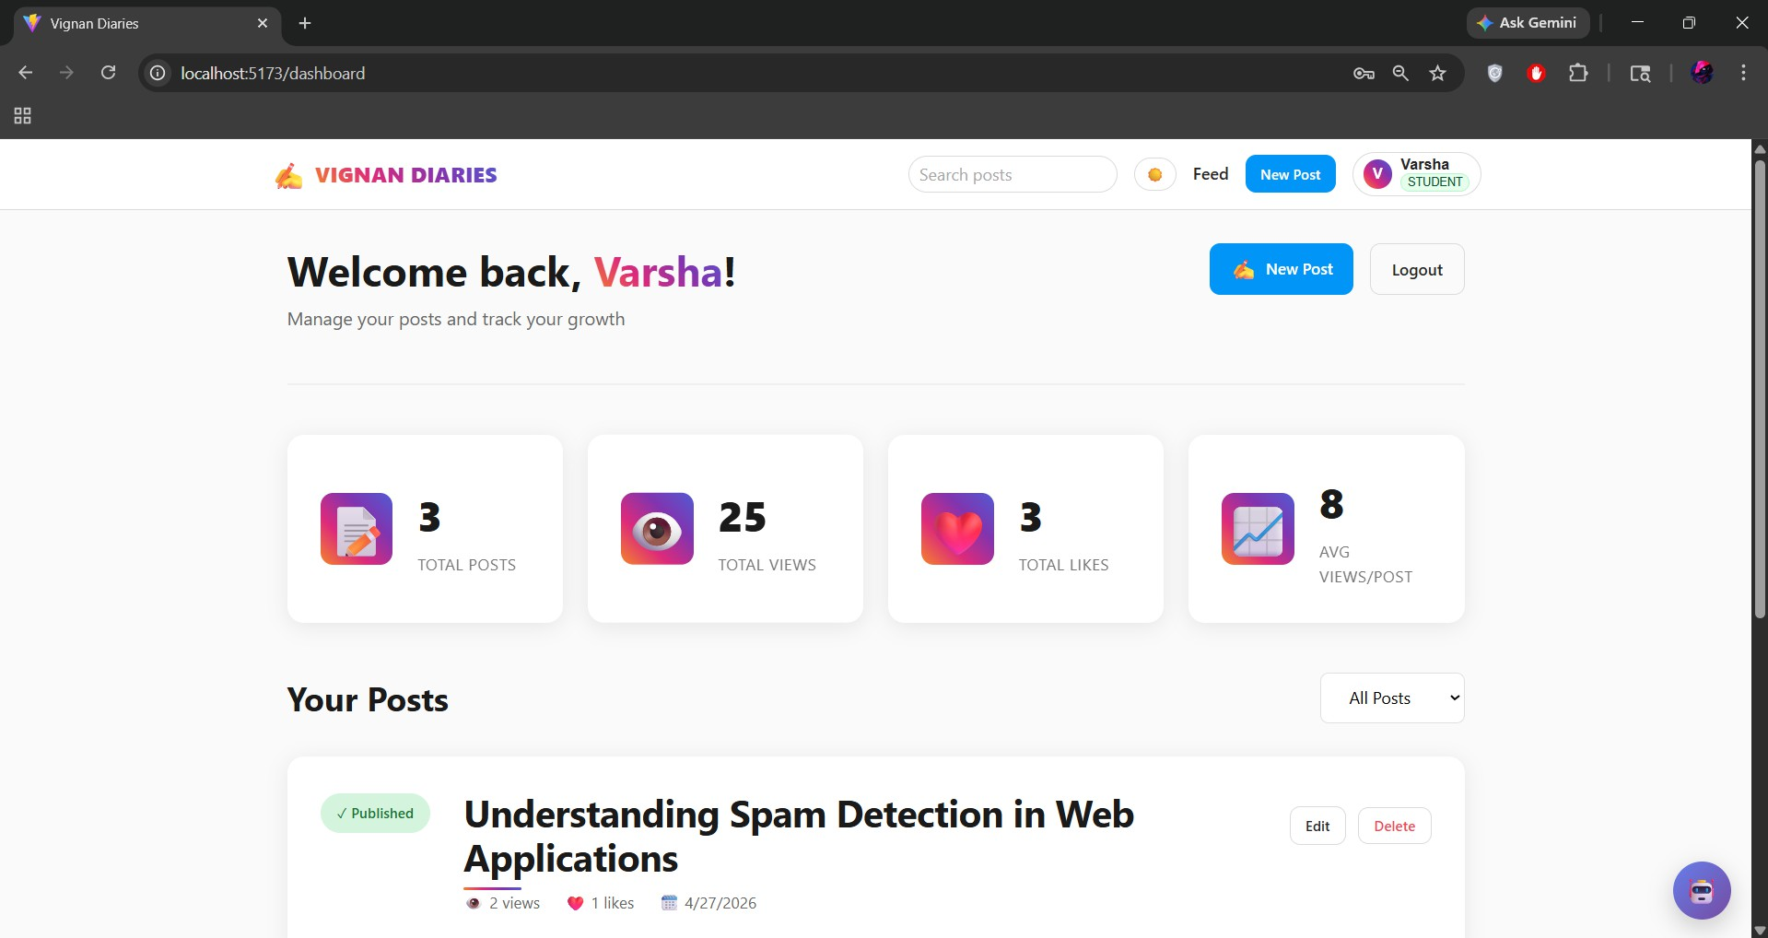

Figure 7.3: User dashboard showing all blog entries

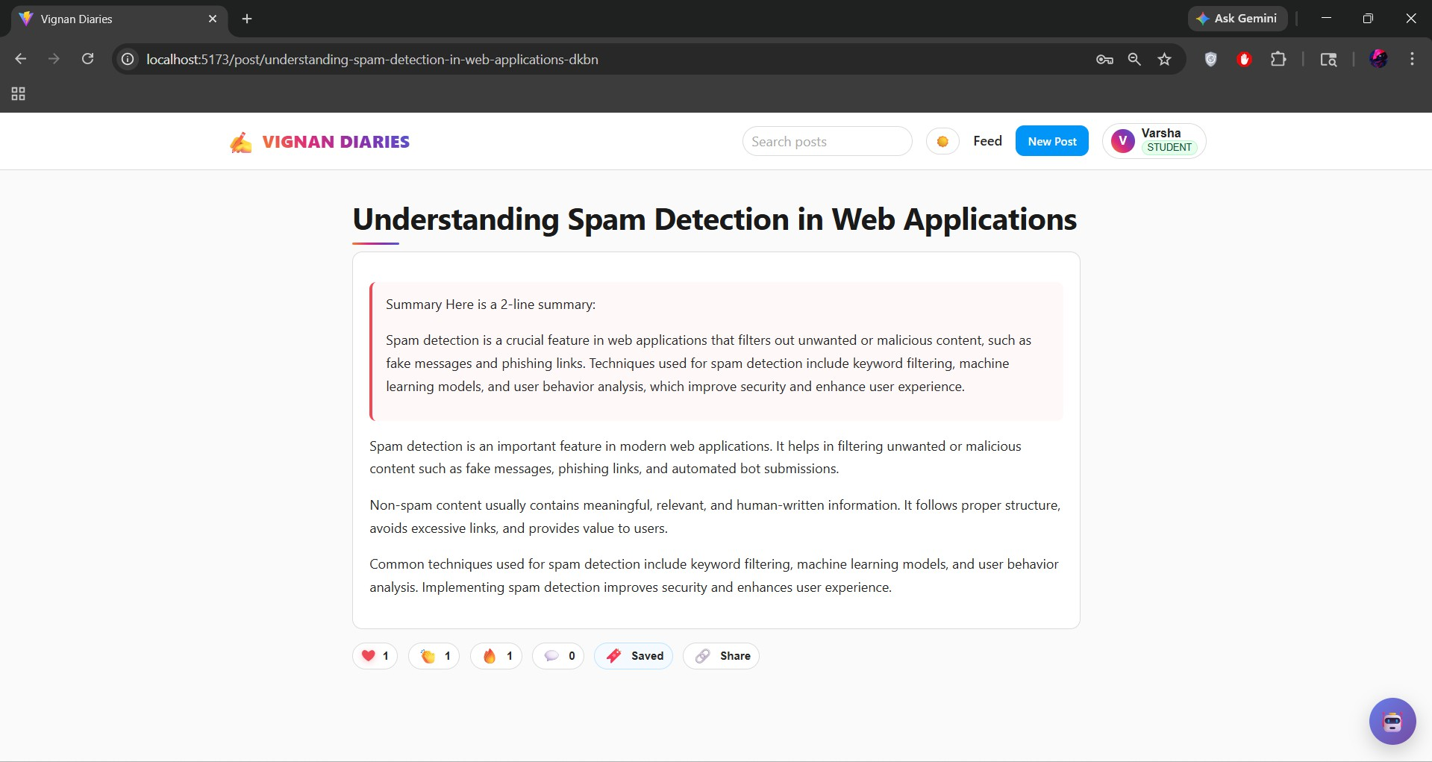

Figure 7.4: Comment, like, and share features

19

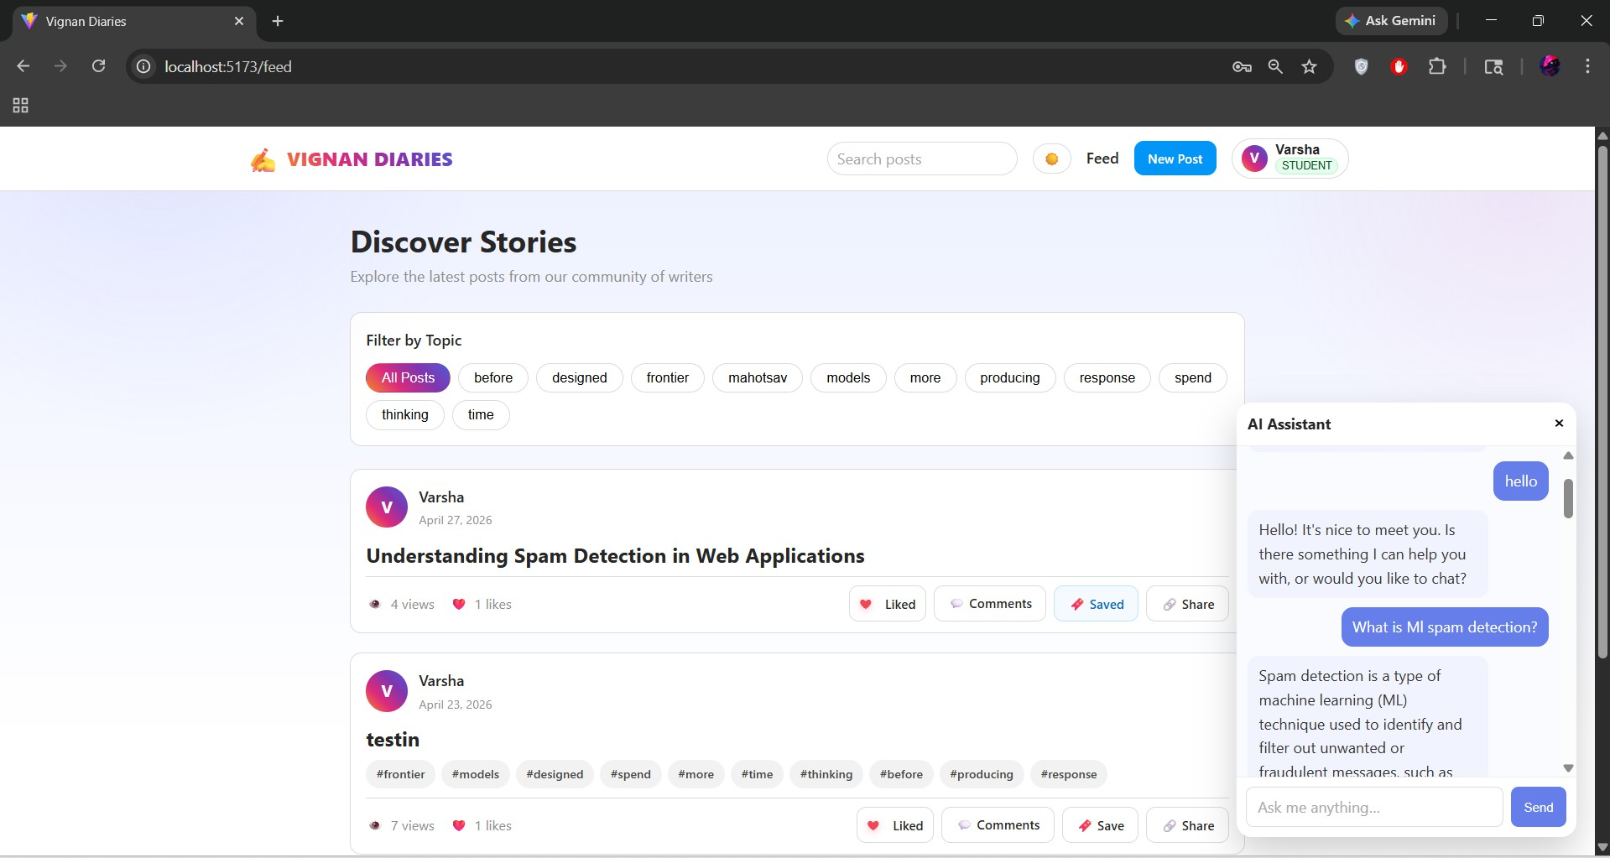

Figure 7.5: AI Implementation

Code Screenshots

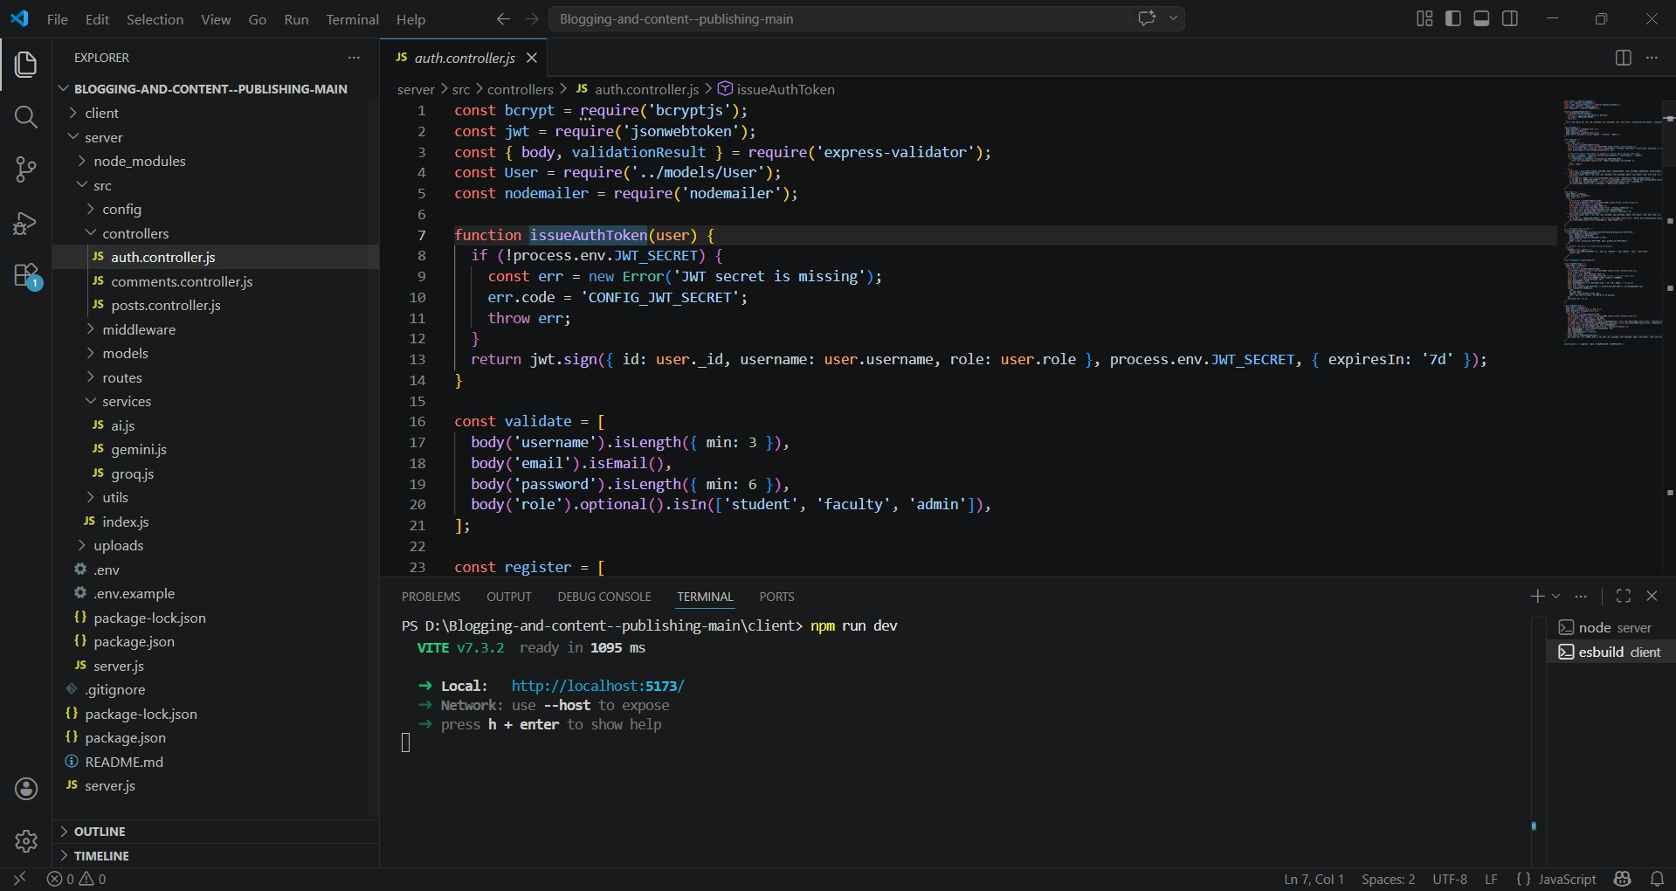

Figure 7.6: JWT Auth Controller (Backend)

20

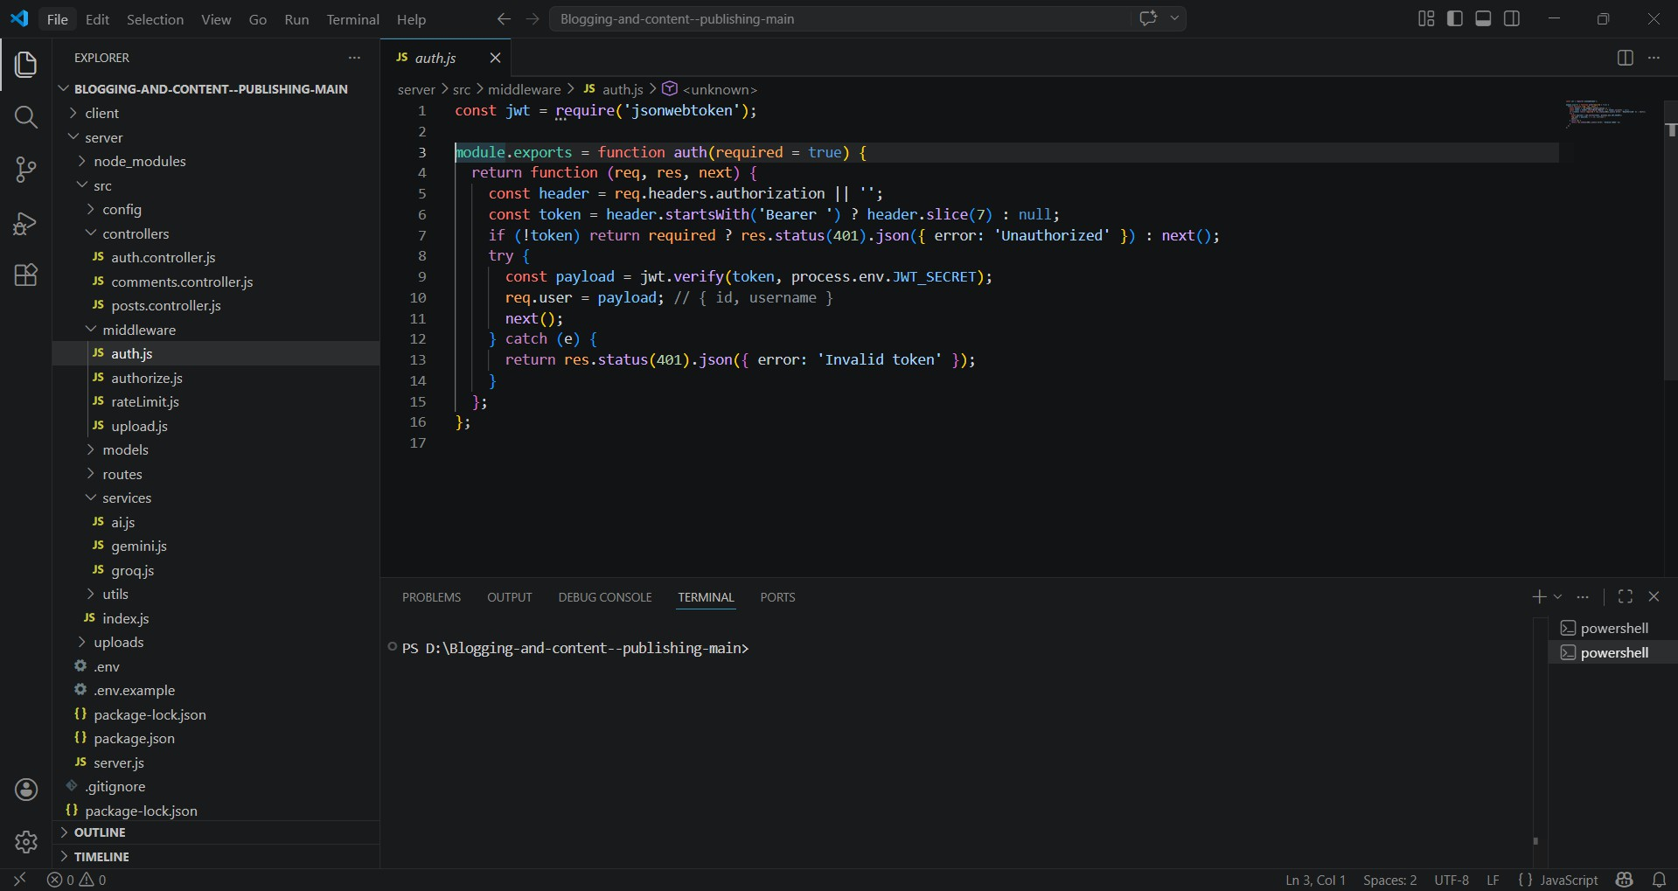

Figure 7.7: Auth Protection Middleware

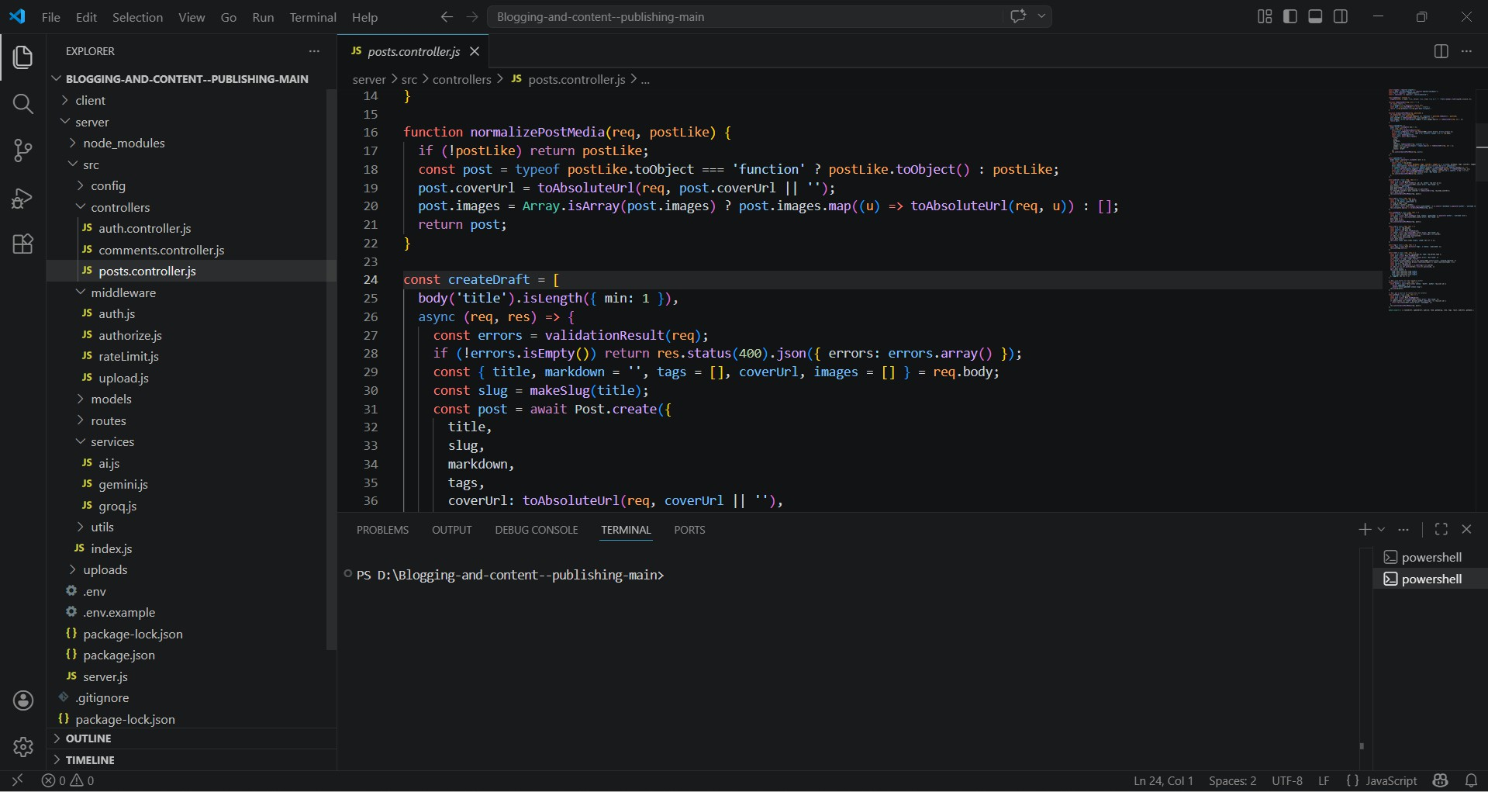

Figure 7.8: Post Lifecycle API (Draft to Publish)

21

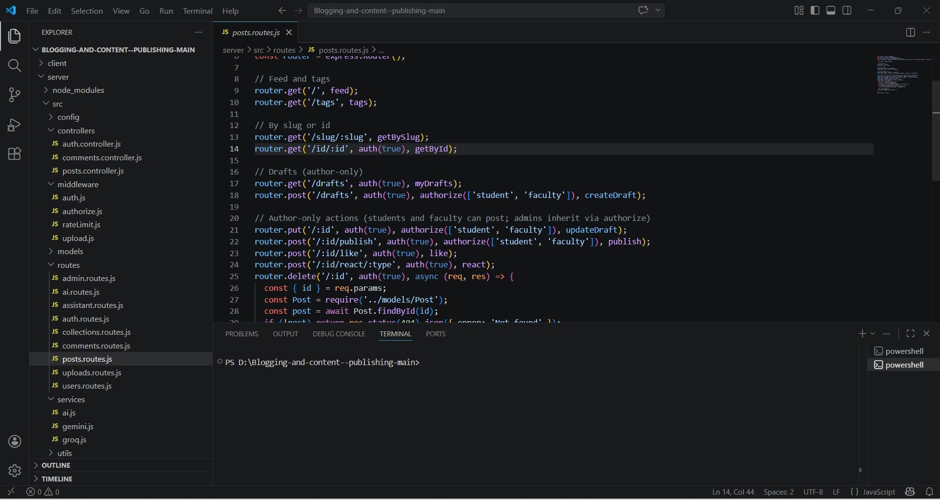

Figure 7.9: Post Engagement Routes (Express)

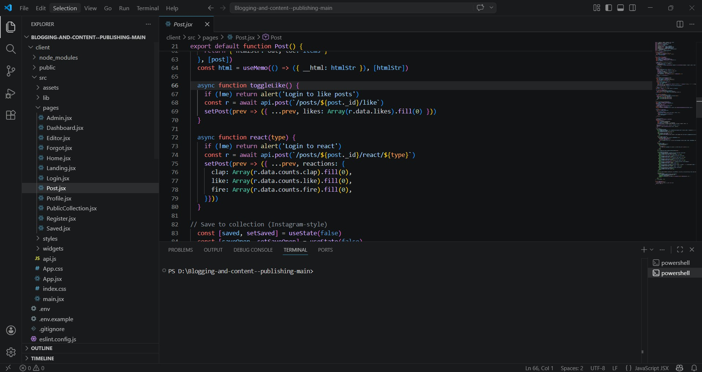

Figure 7.10: Frontend Post Page (Likes + Comments Integration)

22

CHAPTER - 8 URLS

GITHUB URL

GitHub Repository URL:
https://github.com/varshanaradasu/Vignan-Diaries

DEPLOYED URL

Deployed Frontend URL:
https://vignan-diaries.vercel.app

23

